I created a MERN stack application on my laptop after following the instructions from Abhishek Veeramalla’s YouTube project (https://youtu.be/IUpsu2xemrA?si=nsfpQfeQZ3KdGj5Z) .
This project clearly explains the Docker containerization concept, by having the user create a frontend, a backend and a MongoDB container.
I used the source files from Abhishek’s GitHub repository (https://github.com/iam-veeramalla/MERN-docker-compose.git) on to my laptop in order to access the files through Visual Studio on my machine.
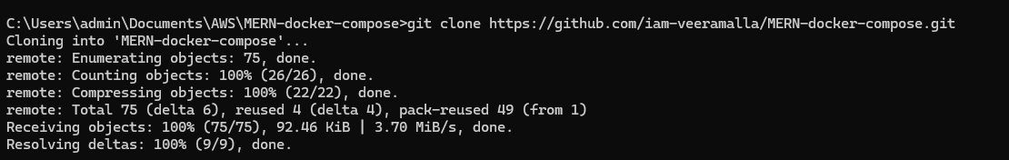

I used Docker Desktop to run the Docker containers on my machine.
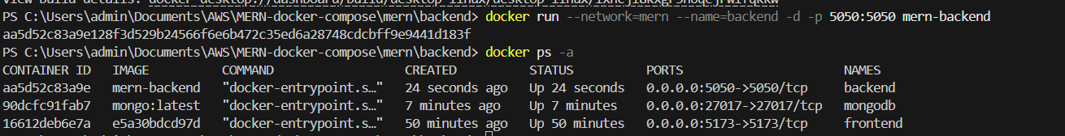
The containers all ran as if they were sperate servers, while they were on the same Docker virtual network, on my local machine.
When everything was running and configured properly, only the Frontend and Backend would return a result on my browser

Front End
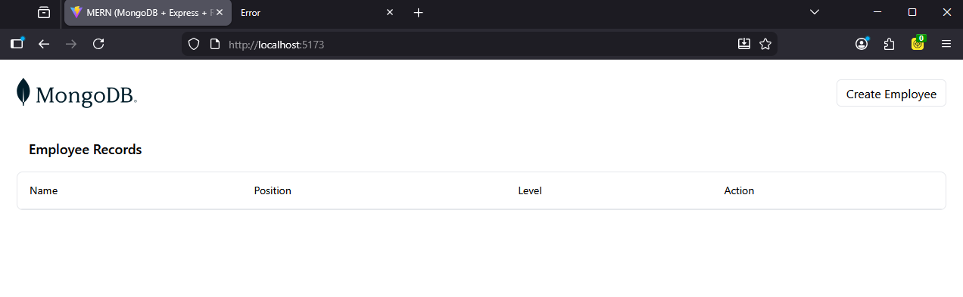

Backend
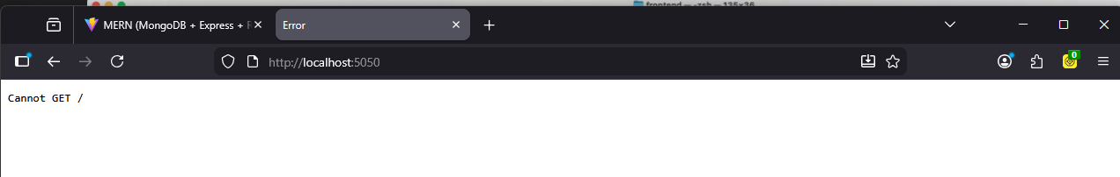

When everything was setup and running, the Frontend image accepted input, and saved that input in the MongoDB container

The Create Employee function displayed
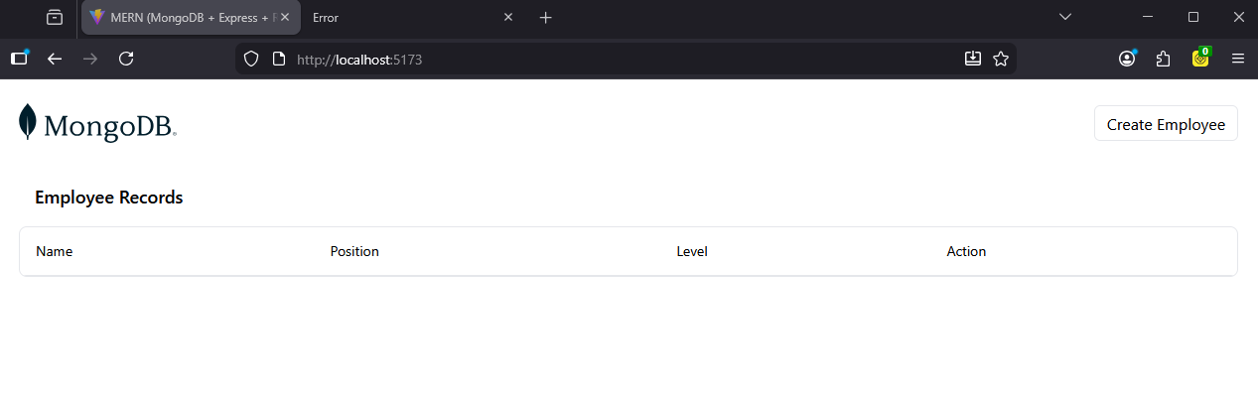
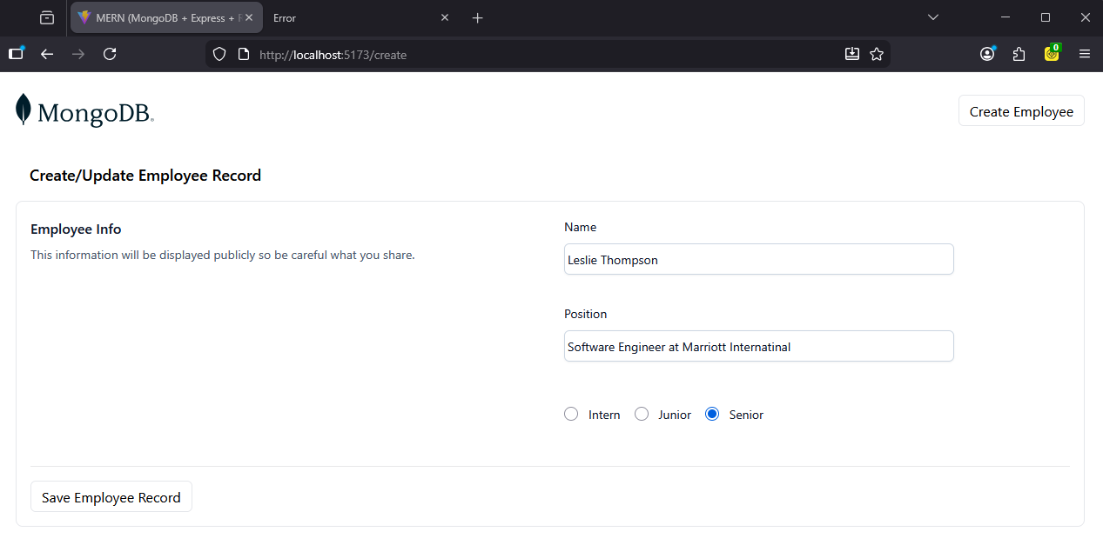

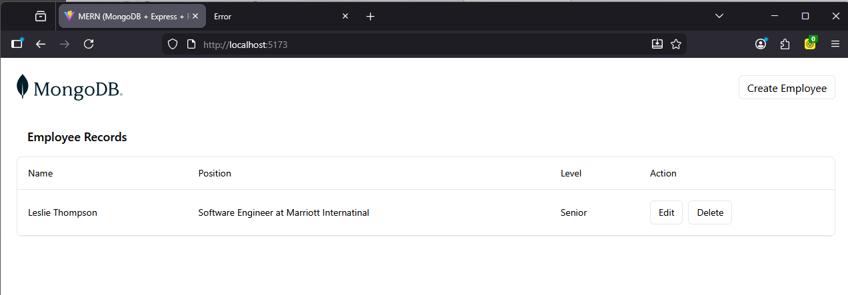

After the Edit function was used
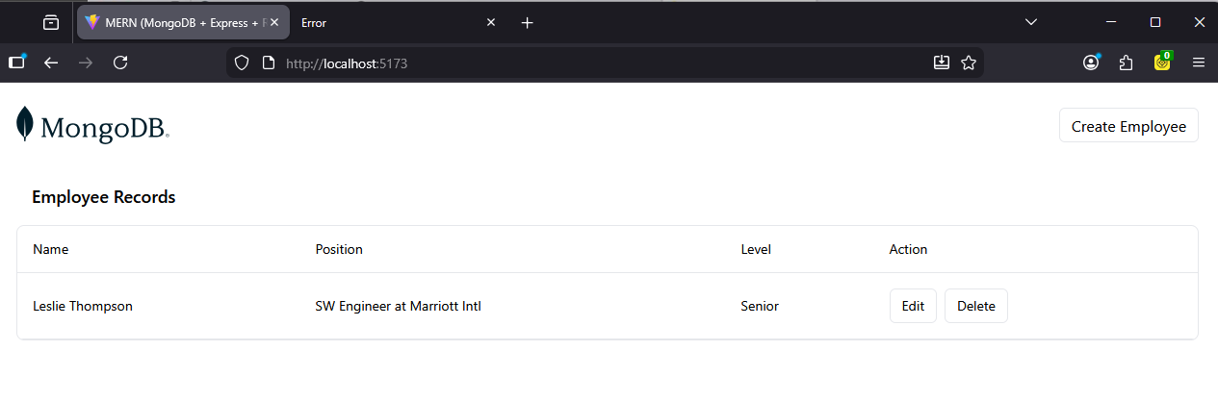

At the end of this tutorial, Abhishek does show the user a way to have Docker create all the containers at once. To me as a professional who has worked in software for over 20 years, this scenario must be examined for every scenario. There may be circumstances where building all containers at once is a logical decision. I generally think that each component of software should be separated during development, to quickly identify points of failure if something goes wrong when an application is running. Also keeping software dependent on other parts of the software often limits the ability to change the application in the future.

